**Visualization research**

We want to visualize the data we gather using a visualization, we have been looking at examples from various sources to try and figure out which would suit our project best.

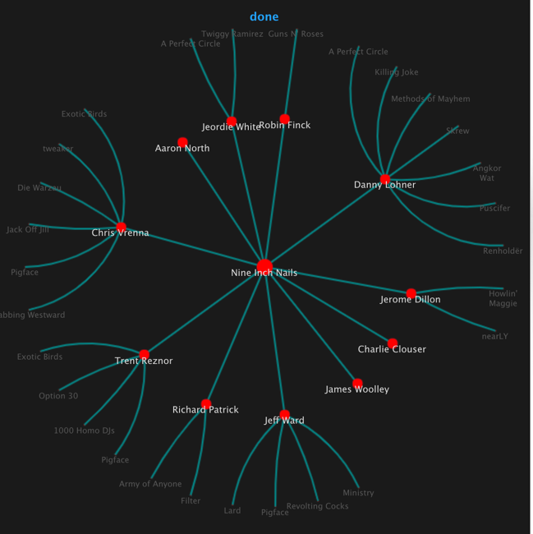

**Tree Animation**

A static JSON Tree structure is used as input for this animation.

Clicking on a node should move the tree and center that node.

The centered node's children are displayed in a relations list in the right column.

<http://philogb.github.io/jit/static/v20/Jit/Examples/Hypertree/example1.html> 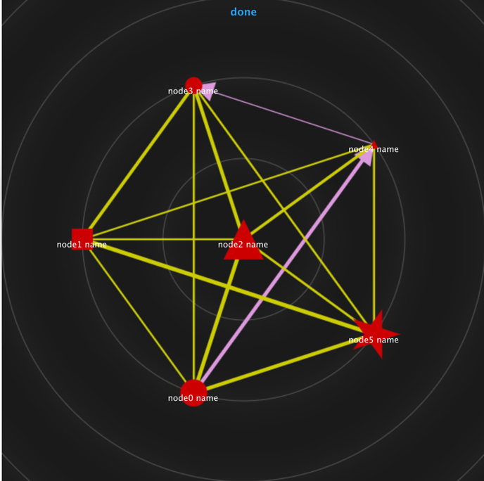

**Weighted Graph Animation**

A static JSON graph structure is used for this animation.

For each JSON node/edge the properties prefixed with the dollar sign ($) set the type of node/edge to be plotted, its style and its dimensions.

<http://philogb.github.io/jit/static/v20/Jit/Examples/RGraph/example2.html>

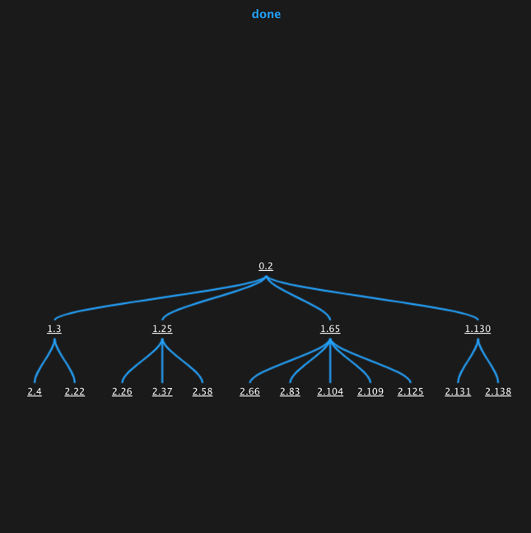

**SpaceTree with on-demand nodes**

This example shows how you can use the **request**controller method to create a SpaceTree with **on demand**nodes

The basic JSON Tree structure is cloned and appended on demand on each node to create an **infinite large SpaceTree.**

[**http://philogb.github.io/jit/static/v20/Jit/Examples/Spacetree/example2.html**](http://philogb.github.io/jit/static/v20/Jit/Examples/Spacetree/example2.html)

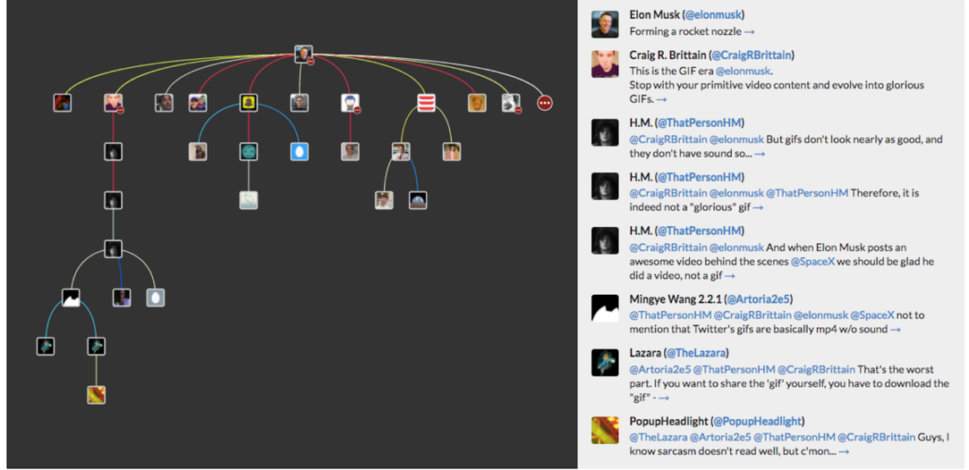

This is a **hypertree** visualisation of a simple conversation. The centre node is the start of the conversation. Each reply goes off in its own thread. Clicking on a node, re-centres the tree

[**https://shkspr.mobi/blog/2017/03/visualising-twitter-conversations-in-2d-space/**](https://shkspr.mobi/blog/2017/03/visualising-twitter-conversations-in-2d-space/)